##### HARIYALI

PROJECT REPORT

###### ***Submitted by***

##### *Bhavya Nyati 20BCE10753*

*Anand Soni 20BCE10858*

*Shaina Shilpi 20BCE10930*

*Anshul Rohilla 20BCE11107*

*in partial fulfillment for the award of the degree* *of*

##### BACHELOR OF TECHNOLOGY

*in*

**COMPUTER SCIENCE AND ENGINEERING**



**SCHOOL OF COMPUTING SCIENCE AND ENGINEERING**

**VIT BHOPAL UNIVERSITY**

**KOTHRI KALAN, SEHORE**

**MADHYA PRADESH - 466114**

DECEMBER, 2021

**VIT BHOPAL UNIVERSITY, KOTHRIKALAN, SEHORE**

**MADHYA PRADESH – 466114**

**BONAFIDE CERTIFICATE**

Certified that this project report titled **“HARIYALI”** is the Bona fide work of ***“Bhavya Nyati (20BCE10753), Anand Soni (20BCE10858), Shaina Shilpi (20BCE10930) and Anshul Rohilla (20BCE11107)”*** who carried out the project work under my supervision. Certified further that to the best of my knowledge the work reported here does not form part of any other project / research work on the basis of which a degree or award was conferred on an earlier occasion on this or any other candidate.

**PROGRAM GUIDE**

Dr Trapti Sharma,

Assistant Professor,

School of Computer Science and Engineering

VIT BHOPAL UNIVERSITY

**PROGRAM CHAIR**

Dr Sandeep Mal,

Senior Assistant Professor,

School of Computer Science and Engineering

VIT BHOPAL UNIVERSITY

The Project Exhibition I Examination is held on 21 December, 2021

**ACKNOWLEDGEMENT**

First and foremost, I would like to thank the Lord Almighty for His presence and immense blessings throughout the project work.

I wish to express my heartfelt gratitude to Dr SANDEEP MAL, Head of the Department, School of Computer Science for much of his valuable support and encouragement in carrying out this work.

I would like to thank my internal guide Dr TRAPTI SHARMA, for continually guiding and actively participating in our project, giving valuable suggestions to complete the project work.

I would like to thank all the technical and teaching staff of the School of Computer Science, who extended directly or indirectly all support.

Last, but not the least, I am deeply indebted to our parents who have been the greatest support while we worked day and night for the project to make it a success.

**LIST OF FIGURES**

|  |  |  |
| --- | --- | --- |
| **FIGURE NO.** | **TITLE** | **PAGE NO.** |
| 5.3.1 | USER FEEDBACK FORM | 22 |
| 5.3.2 | AQI ACCURACY INPUT | 23 |
| 5.3.3 | PIE CHART RATING OF AQI COMMANDS | 23 |
| 5.3.4 | PIE CHART FOR AQI PRECISION | 24 |
| 5.3.5 | USER SUGGESTION | 24 |

**ABSTRACT**

Chatbots, or conversational interfaces as they are also known, present a new way for individuals to interact with computer systems. Traditionally, to get a question answered by a software program involved using a search engine, or filling out a form.

But now, the chatbot allows a user to simply ask questions in the same manner that they would address a human.

The technology at the core of the rise of the chatbot is natural language processing (“NLP”). Recent advances in machine learning have greatly improved the accuracy and effectiveness of natural language processing, making chatbots a viable option for many organizations.

This improvement in NLP is firing a great deal of additional research which should lead to continued improvement in the effectiveness of chatbots in the years to come.

Our project is about a chatbot which will : -

* Allow the people of our country to know the AQI of their place and the overall geography of the place through HariYALI’s afforestation land suggestion feature.
* The chatbot will be made functional on discord as it is one of the most used platforms worldwide.
* Through our efforts of making HariYALI, we aim to make people more aware of hazardous effects of pollutions and the advantages of the afforestation culture.

**TABLE OF CONTENTS**

|  |  |  |
| --- | --- | --- |
| **CHAPTER NUMBER** | **TITLE** | **PAGE NO.** |
|  | List of Figures  Abstract | 4  5 |
| 1 | **PROJECT DESCRIPTION AND OUTLINE** Introduction 1.2 Motivation for the work  1.3 About Introduction to the project including techniques  1.4 Problem Statement  1.5 Organization of the project  1.6 Summary | 8  8  8 – 9  9  9  9 |
| 2 | **RELATED WORK INVESTIGATION**    2.1 Introduction  2.2 Core area of the project  2.3 Existing Algorithms/Approaches  2.3.1 Smokey  2.4 Pros and Cons of existing approaches  2.5 Issues/Observation from investigation  2.6 Summary | 10  10  10  11  11  11 |
| 3 | **REQUIREMENT ARTIFACTS**  3.1 Introduction  3.2 Hardware and Software requirements  3.2.1 Minimum vs Recommended requirements  3.3 Specific Project Requirements  3.3.1 Data Requirements  3.3.2 Function requirements  3.3.3 Performance and security requirements  3.4 Summary | 12  12  12  14 - 16  14  14 – 15  16  17 |
| 4 | **DESIGN METHODOLOGY AND ITS NOVELTY**  4.1 Methodology and Goal  4.2 Functional Modules Design and Analysis  4.2.1 Module – 1, Natural Language Processing  4.2.2 Module – 2, Tokenization  4.2.3 Module – 3, Named Entity Recognition  4.2.4 Module – 4, Learning from Model Building  4.3 Software architectural Design  4.4 Novelty  4.5 User Interface Design  4.6 Summary | 17 – 18  18 – 19  18  18  19  19  19 – 20  20  20  20 |
| 5 | **TECHNICAL IMPLEMENTATION AND ANALYSIS**  5.1Introduction  5.2 Performance Measures  5.3 Performance Analysis (Graphs/Charts) | 21  21  21 – 24 |
| 6 | **PROJECT OUTCOME AND APPLICABILITY**  6.1 Outcomes | 25 |
| 7 | **CONCLUSIONS AND RECOMMENDATIONS**  7.1Outline  7.2 Limitation/Constraints of the System  7.3 Future Enhancements  7.4 Conclusion | 25  25  26  26 |
|  | References | 27 |

**1) INTRODUCTION**

**1.1) Introduction**

**Hariyali** is a Discord Chat Bot which aims at predicting the air quality index and identifying potential land for afforestation. The air quality index is an index for reporting air quality on a daily basis. In other words, it is a measure of how air pollution affects one’s health within a short time period. The AQI is calculated based on the average concentration of a particular pollutant measured over a standard time interval. Generally, the time interval is 24 hours for most pollutants, 8 hours for carbon monoxide and ozone. We can see how air pollution is, by looking at the AQI.

**1.2) Motivation for the Work**

Today we are living in a world where every second technology is multiplying itself enormously. Nowadays there is an application for almost everything. Yet there are many sections of our society which are using the old conventional methods to store data and other stuff.

This application is created in order to create awareness among the Indian Population regarding the Pollution and its rising issues and thereby aims to convey that Pollution is a major and rapidly growing problem and cannot be ignored. The main motivation toward the project building came when we read a news headline stating **“Delhi Pollution : Smog engulfs NCR, Air Quality Index dips to severe category”**, so we decided to take a small step to make **Janta** aware of this rising concern. Till date no application has been made which can both tell the AQI and also the number of trees to be planted each year to overcome its effect.

Hence, HARIYALI will support the environment and will help, all though it’s a small step in favor of the environment, but people will actually know the causes and its hazardous nature .

**1.3) About Introduction to the project including techniques**

It is a project based on a chatbot where python collab is used. In this project, the chatbot replies to the conversation initiated by the user in an apt manner. Here, the user interacts with the chatbot and then the chatbot analyses the text with the help of natural language processing. Then the chatbot responses according to the data stored in the database. With the help of AI and ML the bot can even learn from users, in the form of feedback mechanism. Its learning is directly proportional to the information supplied to it.

**1.4) Problem Statement**

Air pollution is one of environmental issues that cannot be ignored. Inhaling pollutants for a long time causes damages in human health. This project is suitable for air quality monitoring in real-time. Since, deforestation is biggest problem nowadays due to rapid development. So, our project also help people by telling them to plant as many trees as possible, directly and indirectly benefitting the environment.

**1.5) Organization of the project**

The organization of our project is as follows:

**Chapter – 1.** Project description and Outline

**Chapter – 2.** Related work investigation

**Chapter – 3.** Requirement Artifacts

**Chapter – 4**. Design methodology and its novelty

**Chapter – 5.** Technical Implementations and Analysis

**Chapter – 6.** Project outcome and Applicability

**Chapter – 7.** Conclusions and Recommendation

**1.6) Summary**

Successful chatbots are designed to learn, making maintenance an integral part of the chatbot development methodology. Artificial Intelligence is the driving force behind the creation of innovative products like autonomous vehicles and chatbots. Answering frequently asked questions, filing claims, checking the status of an order and getting feedback from customers are among the most popular use cases for chatbots. The chatbot development methodology blends several modern frameworks and methodologies including design thinking, AI innovation sprints, and agile software development. The first step in developing a chatbot is clearly defining its purpose, the problem it is going to solve, and the value it is going to bring to the users. In our case helping the environment is our main motive.

**2) RELATED WORK INVESTIGATION**

**2.1) Introduction**

Our project is based on a chatbot which we are making using python programming language.

**2.2) Core area of the project**

The core area of the project is to develop a platform where people can view the AQI and the factors responsible for that AQI of that particular place. For the same purpose the chatbot has been trained to respond to the user’s requests accordingly. The API extracts data from government-based databases and this has been connected with the chatbot.

**2.3) Existing Algorithms/Approaches**

**2.3.1) SMOKEY :** Smokey brings us real-time air quality data from 48 countries. Most of Smokey’s users live in India, Nepal, France, Germany, the UK, Chile and the US.

Smokey tracks all the primary air pollutants: PM2.5, PM10, NO2, SO2, CO and ozone. For example, if you want to find the air quality of Jaipur on Twitter with Smokey, you simply have to send a tweet “#airairair Jaipur". In the next few seconds, Smokey will grab air quality data from the monitoring stations across Jaipur, then reply to your tweet.

**2.4) Pros and Cons of existing approaches**

Pros –

* Capable of tracking nearly all primary air pollutants.
* Tracks data in real-time.
* Widespread user base.

Cons –

* Contains data from only 43cities/towns in India.
* Unable to tell whether the pollution level is under control or not.
* Cannot provide user with the afforestation feature, unlike Hariyali.
* Relies on Washington DC based organization (OpenAQ) to aggregate the data sources.
* It is twitter based, so every time the user has to tweet to get the required data, which might make his twitter timeline cumbersome and shabby.

**2.5) Issues/Observation from investigation**

This is project is completely a fresh one and unique, for me and my team members. We have gone through a lot of research work, remotely, while investigating about the topic. During our time of research, we’d learned a lot about the environment and how we humans have pressurized upon it for our soulful needs. As a part of our topic, to be specific, our research was mainly focused on the Air Pollution; its causes, how do we control it, why there is a need of awareness creation among masses and as to why is this is an impactful and important theme to be pondered upon. We also learned about the “PM class” of pollutants and its hazardous nature. It is known fact to all of us that, every tiny living organism/particle (speaking in general) on this planet requires oxygen for life support, which, in a way, makes the whole “Air” topic important and as per our observation, during the entirety of our project building, we learned that the PM classes of pollutants and needles to mention the other chemical oxides, are a kind of *‘silent killer’*, killing our environment slowly and steadily. Lastly, I would say that – **“Mother Earth doesn’t owe us anything, but we owe everything to Mother Earth”** so, we must act decisively to protect our planet from both the coronavirus and the existential threat of climate disruption.

**2.6) Summary**

Chatbots New technologies have favored the creation of intelligent and autonomous systems, and among them is the emergence of Chatbots. The term “chatbot” or “chatterbot” indicates a robot that can talk and can be defined as a software that allows the simplification of interactions between humans and machines.

**3) REQUIREMENT ARTIFACTS**

**3.1) Introduction**

In this section we will focus on system requirements as proposed.

* A requirement describes a condition or capability to which a system must conform.
* A requirement is either derived directly from user needs or stated in a contract, standard, specification, or other formally imposed document.
* For example, you can use features and use cases to describe the requirements, and then enhance the definition by creating diagrams, wireframes, or storyboards.
* *Artifact* is a general term for an object in a repository.
* You can manage artifacts in projects and folders, or you can use tags to filter groups of artifacts for a specific purpose.

The chatbot replies to the conversation initiated by the user in an apt manner. Here, the user interacts with the chatbot and then the chatbot analyses the text with the help of natural language processing. Then the chatbot responses according to the data stored in the database. The chatbot learns after interacting with the lot of users with the help of human interactions and API’s. The more the information the chatbot gets, the more it learns to respond accurately

**3.2) Hardware and Software requirements**

* System requirements are the required specifications a device must have in order to use certain hardware or software.
* For example, a computer may require a specific I/O port to work with a peripheral device. A smartphone may need a specific operating system to run a particular app.
* Software requirements for this system are as listed follows:

1. Operating system
2. Minimum CPU or processor speed
3. Minimum GPU or video memory
4. Minimum system memory (RAM)
5. Minimum free storage space

**3.2.1 Minimum vs Recommended Requirements-**

* Some products include both minimum and recommended system requirements.
* A video game, for instance, may function with the minimum required CPU and GPU, but it will perform better with the recommended hardware.
* A more powerful processor and graphics card may produce improved graphics and faster frame rates (FPS).
* Some system requirements are not flexible, such as the operating system(s) and disk space required for software installation.
* Others, such as CPU, GPU, and RAM requirements may vary significantly between the minimum and recommended requirements.
* When buying or upgrading a software program, it is often wise to make sure your system has close to the recommended requirements to ensure a good user experience.
* Below is an example of minimum versus recommended system requirements for a Windows application.
* **OS:** Windows 7 with SP1; (*Recommended:* Windows 10)
* **CPU:** 750MHz Intel or AMD processor with 64-bit support; (*Recommended:* 2.8 GHz or faster processor)
* **Disk Storage:** 200 MB of free disk space
* RAM: 256 MB or above
* **Monitor Resolution:** 1280x800; (*Recommended:* 1920x1080)

**3.3**  **Specific Project requirements**

* Imagine that you're building your dream house. You've purchased the land, hired the architect, and secured your construction crew. That's a good place to start, but without your blueprint, your dream house will remain just that: a dream. Your blueprint gives the architect, contractor, electrician, plumber, and anyone involved in the build, a clear idea of what needs to be done to finish the house. This plan provides them with the requirements needed to complete their jobs.
* **Project requirements** are conditions or tasks that must be completed to ensure the success or completion of the project.
* They provide a clear picture of the work that needs to be done. They're meant to align the project's resources with the objectives of the organization.
* The benefits of effectively gathering project requirements include cost reduction, higher project success rates, more effective change management, and improved communication among stakeholders.

**3.3.1 Data Requirement**

* Data requirements definition **establishes the process used to identify, prioritize, precisely formulate, and validate the data needed to achieve business objectives**.
* When documenting data requirements, data should be referenced in business language, reusing approved standard business terms if available.
* The main data that are required in our program are given as follow:

1. Discord app
2. Station location
3. Plants

**3.3.2 Function Requirement**

Installation

**First,** you'll need the discord python libraries,  
pip3 install discord –user

**Secondly,** visit this url to create the application,  
<https://discordapp.com/developers/applications/>

(Feel free to customize it's application name and it's image before saving changes)

**Thirdly,** you'll need to turn your application into a bot, by visiting this url and generating it's token,  
[https://discordapp.com/developers/applications/<client id>/bots](https://discordapp.com/developers/applications/%3cclient%20id%3e/bots)

**Finally** visit this page and configure permissions to get your adding link generated,  
<https://discordapi.com/permissions.html>

Here is an example:  
<https://discordapi.com/permissions.html#199680><https://discordapp.com/oauth2/authorize?client_id=INSERT_CLIENT_ID_HERE&scope=bot&permissions=199680>

**WARNING:** Don't forget to insert your bot token in the code.

Upon joining the server our bot welcomes you with a warm welcome message which is specially crafted for nature-lover like you and our team!!

**>about_hariyali_bot** and on typing the command it tells, and the quote - I see a future where getting to work or to school or to the store does not have to cause pollution. And we’re glad to inform that it is capable of predicting the AQI and the potential land for afforestation

**>help** – It will show a menu, which would tell all the commands which our bot can run.

**>aqi_help** : It will show us a menu of two commands with the description of what function they are meant to perform.

>**aqi_brief** : It will give us a brief information about the Air Quality with a list of some potential air pollutants which are a threat to environment. Now if you are curious nature-lover like our team then you can definitely give a read by clicking on the link below.

**>aqi_act** : It will give us some brief resources about the effect of air pollution on our environment which includes smog, soot, hazardous air pollutants like carbon monoxide and nitric oxide, the greenhouse gases. Now again, if you are a curious reader then don’t forget to ponder over the links provided by our bot especially for nature-lover like you.

Now you might be wondering how the AQI of a place is calculated, our team again got you covered.

The AQI is calculated based on the average concentration of a particular pollutant measured over a standard time interval (24 hours for most pollutants, 8 hours for carbon monoxide and ozone)

For example, the AQI for PM2.5 is based on 24-hour average concentration and

The final AQI is equal to the highest of the AQI values calculated separately for each '

'pollutant, and the corresponding pollutant is also reported

So now lets know about the AQI of a place for this we type the command

**>AQI cityname** like- AQI delhi

It will tell us the aqi of delhi which is pretty high and hazardous for sensitive people

Let us see how is the AQI at Bhopal for this we type -   
**>AQI Bhopal** and as we can see its moderate but still quite damaging for sensitive people.

Now we all know that high AQI is pretty dangerous for the environment and for human beings as a whole so, what shall we do to overcome its effect.

**>most_cleanest_city –** This command will tell us the top 10 most cleanest cities in india.

Now with every good some bad is always associated so lets type the command >**most_polluted_city –** and this command, as it states gives the 10 most polluted cities in india.

**>afforestation –** It gives us a list of commands with a short description as to what they are meant to perform, so these are –

**>afforestation_city –** which gives us last 10 years data of the city and lets see the data to delhi so we type   
>afforestation_delhi and shows us a colorful graph with some AQI information underneath.

**>planting_trees –** it displays the number of trees to be planted based on the aqi ranges and our team has categorized it to a 6level scale which is –

|  |  |  |
| --- | --- | --- |
| **AQI Level** | **AQI Range** | **No. of Tress** |
| **Good** | **0-50** | **1 daily** |
| **Satisfactory** | **51-100** | **10 daily** |
| **Moderate** | **101-200** | **100 daily** |
| **Poor** | **201-300** | **1000 daily** |
| **Very Poor** | **300+400** | **10,000 daily** |
| **Severe** | 401-500 | **100,000 daily** |

Now we all know that high AQI is pretty dangerous for the environment and for human beings as a whole so, what shall we do to overcome its effect.

So lets see what Hariyali recommends us –

To get the recommendation we type

**>how_to_be_safe –** now it shows us an organized image which displays some recommendation based on the AQI range your current city falls into.

**3.3.3) Performance and security requirements**

* Have you ever heard the old saying “You get what you get and you don’t get upset”? While that may apply to after-school snacks and birthday presents, it shouldn’t be the case for software security.
* Software owners don’t just accept any new software features that are deployed; features must go through a strategic process of critique, justification, and analysis before being deployed.
* Your teams should treat security with the same attention to detail. After all, secure software doesn’t just happen out of nowhere—it has to be a requirement of the strategic development process.
* To deploy secure software effectively, you need clear, consistent, testable, and measurable software security requirements.
* To build good requirements, make sure that you’re answering questions about your requirements.
* A software security requirement should be much like a functionality requirement; it shouldn’t be vague or unattainable. Anticipate developers’ questions and answer them ahead of time. Here’s how:

1. **Is this testable?** Can we test this requirement in the final application? “Be secure” is not a testable requirement. “Encode all user-supplied output” is.
2. **Is this measurable?** When we test for this, can we determine coverage and effectiveness?
3. **Is this complete?** Are we forgetting something? Are we mandating checks for user-supplied data to databases but not logs?
4. **Is this clear?** Will the people responsible for designing, implementing, testing, and delivering on this requirement understand the intent of the requirement?
5. **Is this unambiguous?** Could someone interpret this requirement in any other ways?
6. **Are these requirements consistent?** Are we approaching each security requirement in the same way to ensure that the security measures are applied consistently across the board?

**3.4 Summary**

* **Artifact** is highly associated and related to specific methods or processes of development. Methods or processes can be project plans, business cases, or risk assessments.
* Distinct gathering and collections of detailed information are generally organized and incorporated into artifact sets. A set generally represents complete aspect of system.
* This is simply done to make development and establishment of complete software system in manageable manner.
* **Many artifact types are included in the sample project templates, including these types:**

1) Requirements.

2) Use cases.

3) Design documents.

4) Architectural process diagrams.

5) Use case diagrams.

**4) DESIGN METHODOLOGY AND IT’S NOVELTY**

**4.1) Methodology and Goal**

Successful chatbots are designed to learn, making maintenance an integral part of the chatbot development methodology. Artificial Intelligence is the driving force behind the creation of innovative products like autonomous vehicles and chatbots.

Answering frequently asked questions, filing claims, checking the status of an order and getting feedback from customers are among the most popular use cases for chatbots. The chatbot development methodology blends several modern frameworks and methodologies including design thinking, AI innovation sprints, and agile software development.

The first step in developing a chatbot is clearly defining its purpose, the problem it is going to solve, and the value it is going to bring to the users.

In our case helping the environment is our main motive.

**4.2) Functional Module Design and Analysis**

**4.2.1) Module 1, Natural Language Processing**

Natural Language Processing (NLP) is a theory-motivated range of computational techniques for the automatic analysis and representation of human language.

According to Lehnert and Ringle (2014), research on NLP should not be mistaken by speech recognition but is concerned with the symbolic manipulations of meaning and interface that are needed once words are recognized. In fact, a speech recognition algorithm needs to be paired to a language processing program in order to implement actual verbal dialogues with computers.The authors Cambria and White state that NLP research is in a paradigm shift, they are no longer based on techniques of recognition and understanding of loose words. But now begin to explore semantic techniques more consistently, which the authors call a jump from syntactics curve to the semantics curve, and ultimately will arrive at the pragmatics curve, where computational programs will be able to investigate and build entire narratives.

Chatbots New technologies have favored the creation of intelligent and autonomous systems, and among them is the emergence of Chatbots. The term “chatbot” or “chatterbot” indicates a robot that can talk and can be defined as a software that allows the simplification of interactions between humans and machines.

**4.2.2) Module 2, Tokenization**

Given a character sequence and a defined document unit having sentences, tokenization breaks it up into pieces, called tokens, perhaps at the same time throwing away certain characters, such as punctuation. A token is an instance of a sequence of characters in some particular document that are grouped together as a useful semantic unit for processing.

**4.2.3) Module 3, Named Entity Recognition**

While building any conversational bots/ Dialog system one can employ the following approaches to do so we use Retrieval Based Approach

* Generative Based
* Retrieval Based
* Heuristic Based

**4.2.4) Module 4, Learning from Model Building**

Precise and Localized Answers

Specificity and localization were identified as keys to the information needs of Users. With the help of Environmental Protection Agency (EPA), the researchers carefully tailored the system responses to local conditions. Participants appreciated such information contents.

Trust - Trust is another key design requirement. In general, participants trusted the responses

Stories — Stories define the sample interaction between the user and chatbot in terms of intent and action taken by the bot.

Actions — Actions are basically the operations performed by the bot either asking for some more details to get all the entities or integrating with some APIs or querying the database to get/save some information.

**4.3) Software Architectural Designs**

The first thing that happens with all the applications is the user interaction, so, with HariYALI it's no different, the user interacts by passing the request for the information which the user needs, HariYALI then interprets and analyzes the request which is an API call and with the help of NLP which helps **chatbots to understand, analyze and prioritize the questions according to the complexity** and this enables bots to respond to customer queries faster than a human being and it is just a matter of fact that, faster responses help in building user trust and subsequently, more users.

After this the chatbot comes up with an answer to users request by using the data from its database.

Needless to mention, with the help of AI and ML the bot can even learn from users, in the form of feedback mechanism. Its learning is directly proportional to the information supplied to it.

The chatbot’s API helps to combine NLP with combination of chatbot logic and there by helping to deliver and solve relevant problems of the user.

**4.4) Novelty**

The Chatbot is a fresh project for all of us.

With this Chatbot we tend to bring transparency and decrease pollution.

This is completely a fresh idea for the benefits of the Scientist in our Country.

HariYALI is unique because of its idea and the way we want to implement it.

As per our Research, till date there is not chatbot in India that is dedicated to Scientist. So, with this we want to initiate the idea of Technology in every domain.

Not only this, HariYALI main aim is to make EARTH POLLUTION FREE.

**4.5) User Interface Designs**

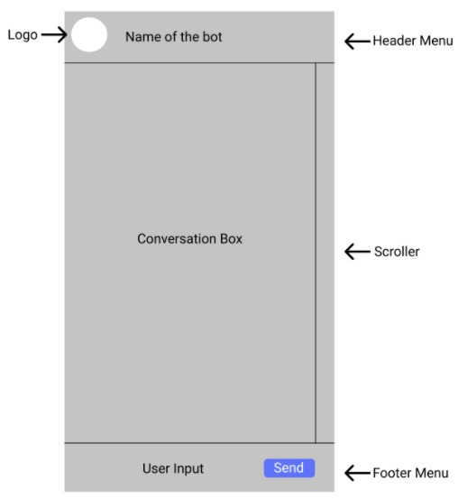 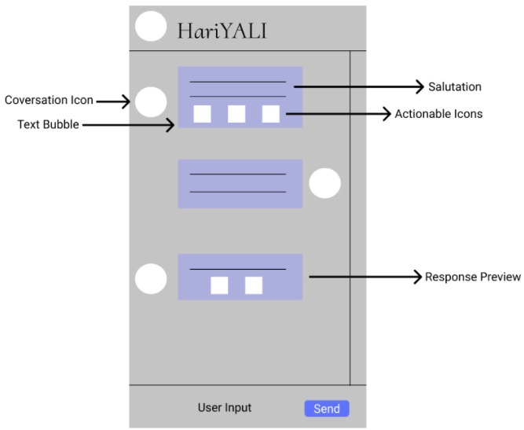

**4.6) Summary**

Hence from here we saw how the whole project has been executed till present. The whole project has been divided into four modules discussed above. We can come to the conclusion that the main crust of the chatbot lies in the chatbot training and the data saved in the API and database. This is so as the chatbot response comes from the API and database and the apt reply comes from the proper chatbot training.

**5) Technical Implementations and Analysis**

**5.1) Introduction**

Graphs are used to review the overall functioning of the project. Performance analysis will ensure us of the functioning of our chatbot. It will tell us of the total users using the chatbot and about the major activities being carried out via this project.

**5.2) Performance measures**

Performance measures depends upon the following measures:

* Money spent on equipment: which is our laptop
* Number of hours worked on the project: around 3 months
* Facility costs: none
* Total operating expenditures: null
* Rental fees: none

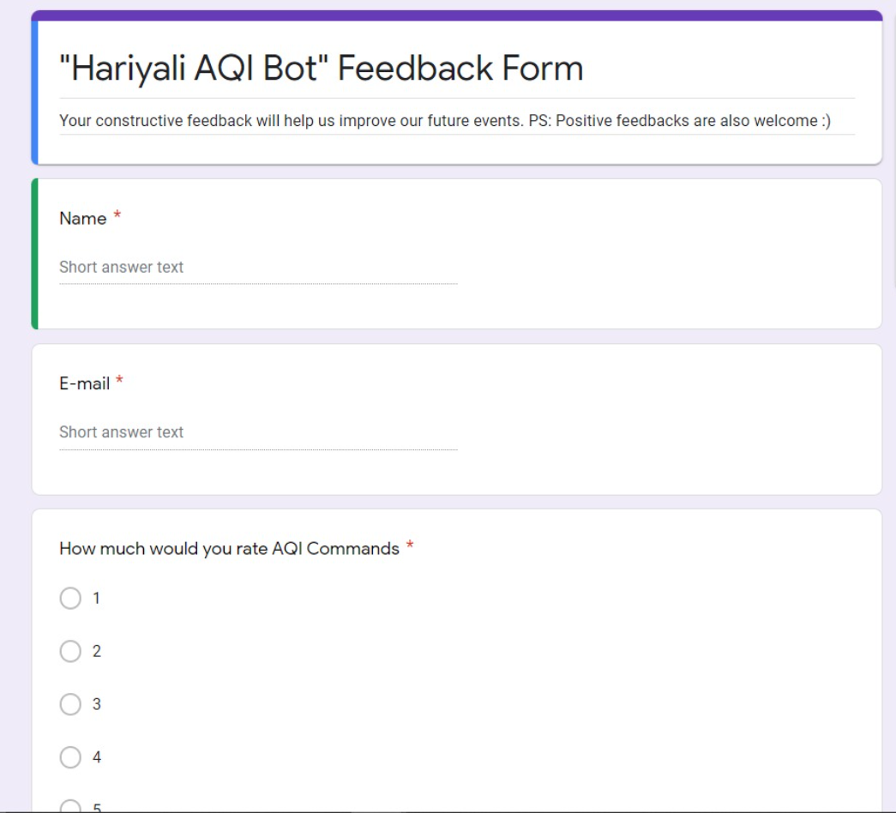**5.3) Performance Analysis**

(**5.3.1)**

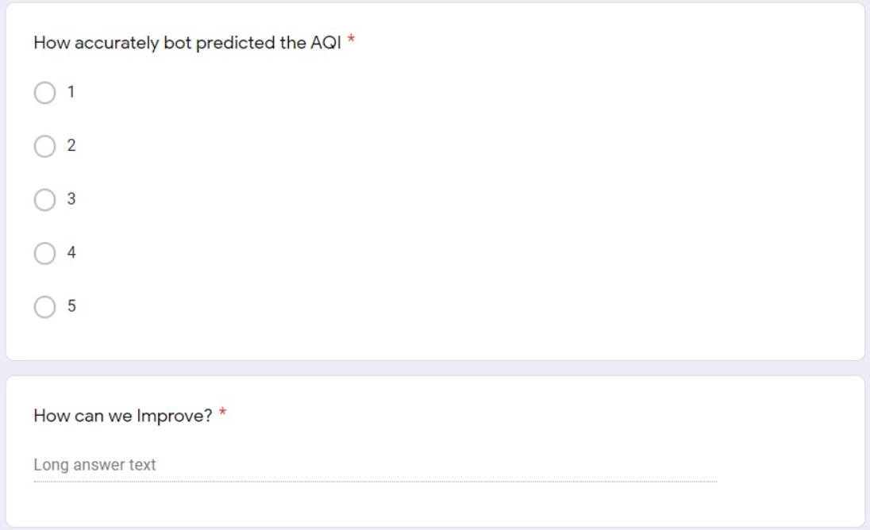**(5.3.2)**

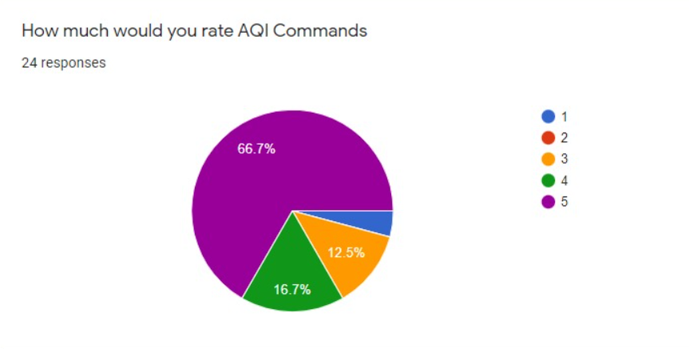(**5.3.3)**

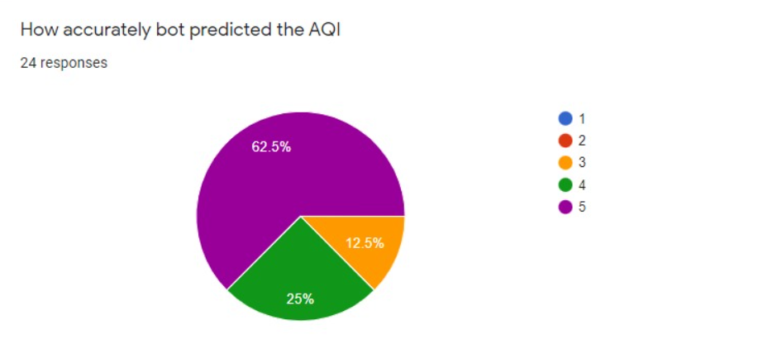

(**5.3.4)**

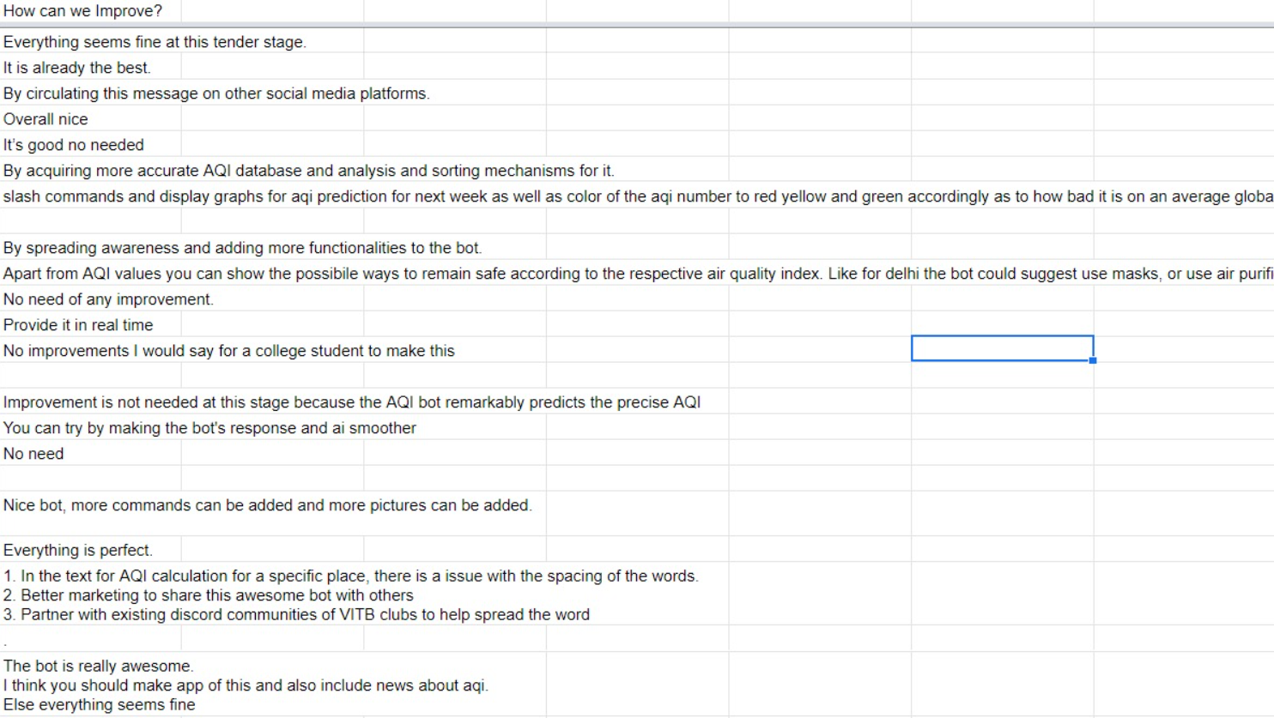(**5.3.5)**

**6) Project Outcome and Applicability**

**6.1) Outcomes**

The main outcome of the “HariYALI bot ” is to make environment pollution free. HariYALI is mainly to determine AQI of various cities and suggest potential land for afforestation. Using this bot we can see the Air Quality Index of particular place and can suggest some ways to improve the air quality of that place. User can easily generate the AQI by typing command >AQI (name of place).

**7) Conclusion and Recommendation**

**7.1) Outline**

Hariyali is an application which aims to display the AQI with an added feature of afforestation scheme thereby creating awareness for our *“hara-bhara”* environment. It overcomes many limitations such as Easy implementation environment and simplified user commands.

**7.2) Limitation/Constraints of the System**

Following are the Limitations and Constraints of Hariyali that we want to work upon in future:

* At present it covers urban and some rural areas, but our objective is to make it accessible to the farthest corner we can go.
* We want to integrate an internal database to store user information like name, email, city of residence and a very basic detail about his/her travel/location history, so that the AQI’s can be compared with ease.
* Various useful commands have been created for simplified user experience. But, we want to add a kind of reward system by which the user will be rewarded (nature of reward will be decided as per the work on this dimension progresses) for every progressive act, out of some listed tasks/fun activities, he does towards environment preservation.

**7.3) Future Enhancements**

We intend to continue to develop this model to increase the relevance and accuracy in data.

Our next steps are as follows:

-Increase the datasets that are available for this model to learn from training(user feedback).

-Increase the number of data’s and query types, basically we want to create a one stop solution for most the environment (mostly dealing with air related problems) related issues.

-We hope that our system will bring a significant change in our locality. A new, updated and expanded edition of our project is to implement the cloud computing function to increase the rise of users accessibility, and to translate the system into Regional language with voice assistance so that it can become very handy for locals, who don’t very well understand English language, of every state. This work is not a one-time job but is a continuous work to be adopted for further research and the system can be used in various “what-if” scenarios. The project has a very vast scope in future. The project can be implemented on the internet in future. Project can be updated in near future as and when requirement for the same arises, as it is very flexible in terms of expansion.

**7.4) Inference**

A transparent and easy operating platform - Hariyali - where users can get knowledge of Air Quality Index and act of pollution and also find AQI. We believe that the application that is developed as a result of these ideas would be beneficial and efficient in today's world. This paper introduced those applied outlines and improvement of provision for environment conveyance. Join us in this journey, as a four-member team cannot alone make this project reach its future heights. We are committed to supporting your faith and beliefs.

**REFERENCES**

* + <https://github.com/python-discord/bot>
  + <https://www.analyticsvidhya.com/blog/2021/07/how-to-analyse-air-pollution-using-python/>
  + <https://www.geeksforgeeks.org/predicting-air-quality-index-using-python/>
  + <https://pythonawesome.com/texting-service-to-receive-current-air-quality-conditions-and-maps/>